**Build a Serverless Web Application**

Time Spent: 120 min

**Overview**

In this module you'll configure Amazon Simple Storage Service (S3) to host the static resources for your web application. In subsequent modules you'll add dynamic functionality to these pages using JavaScript to call remote RESTful APIs built with AWS Lambda and Amazon API Gateway.

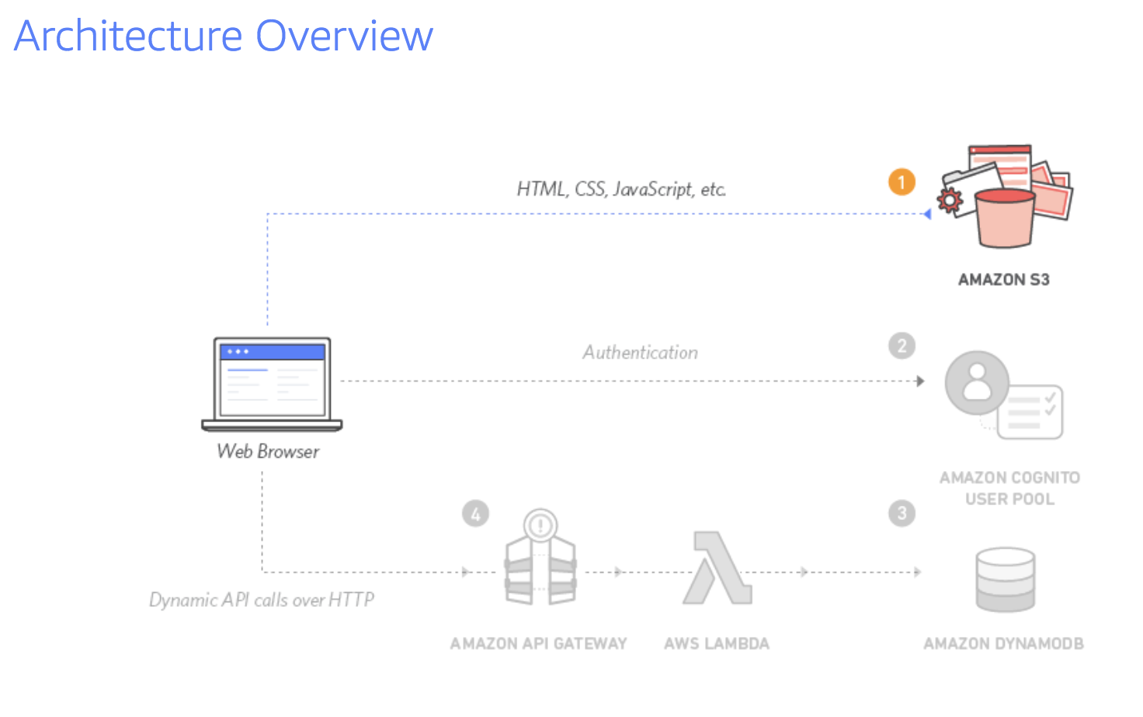

**Related components:**

* AWS Cognito
* AWS API Gateway
* AWS S3
* AWS DynamoDB
* AWS Lambda

**What I learned:**

* How to use AWS S3 bucket to host the static frontend webpage
* Use AWS Cognito to create user pool and ID, to implement the sign-in authentication function
* Implement register and verification function by Cognito
* How to build and deploy the new Gateway API
* How to build the authorization by Cognito token

**What I built:**

* Use AWS S3 bucket to host the static frontend webpage

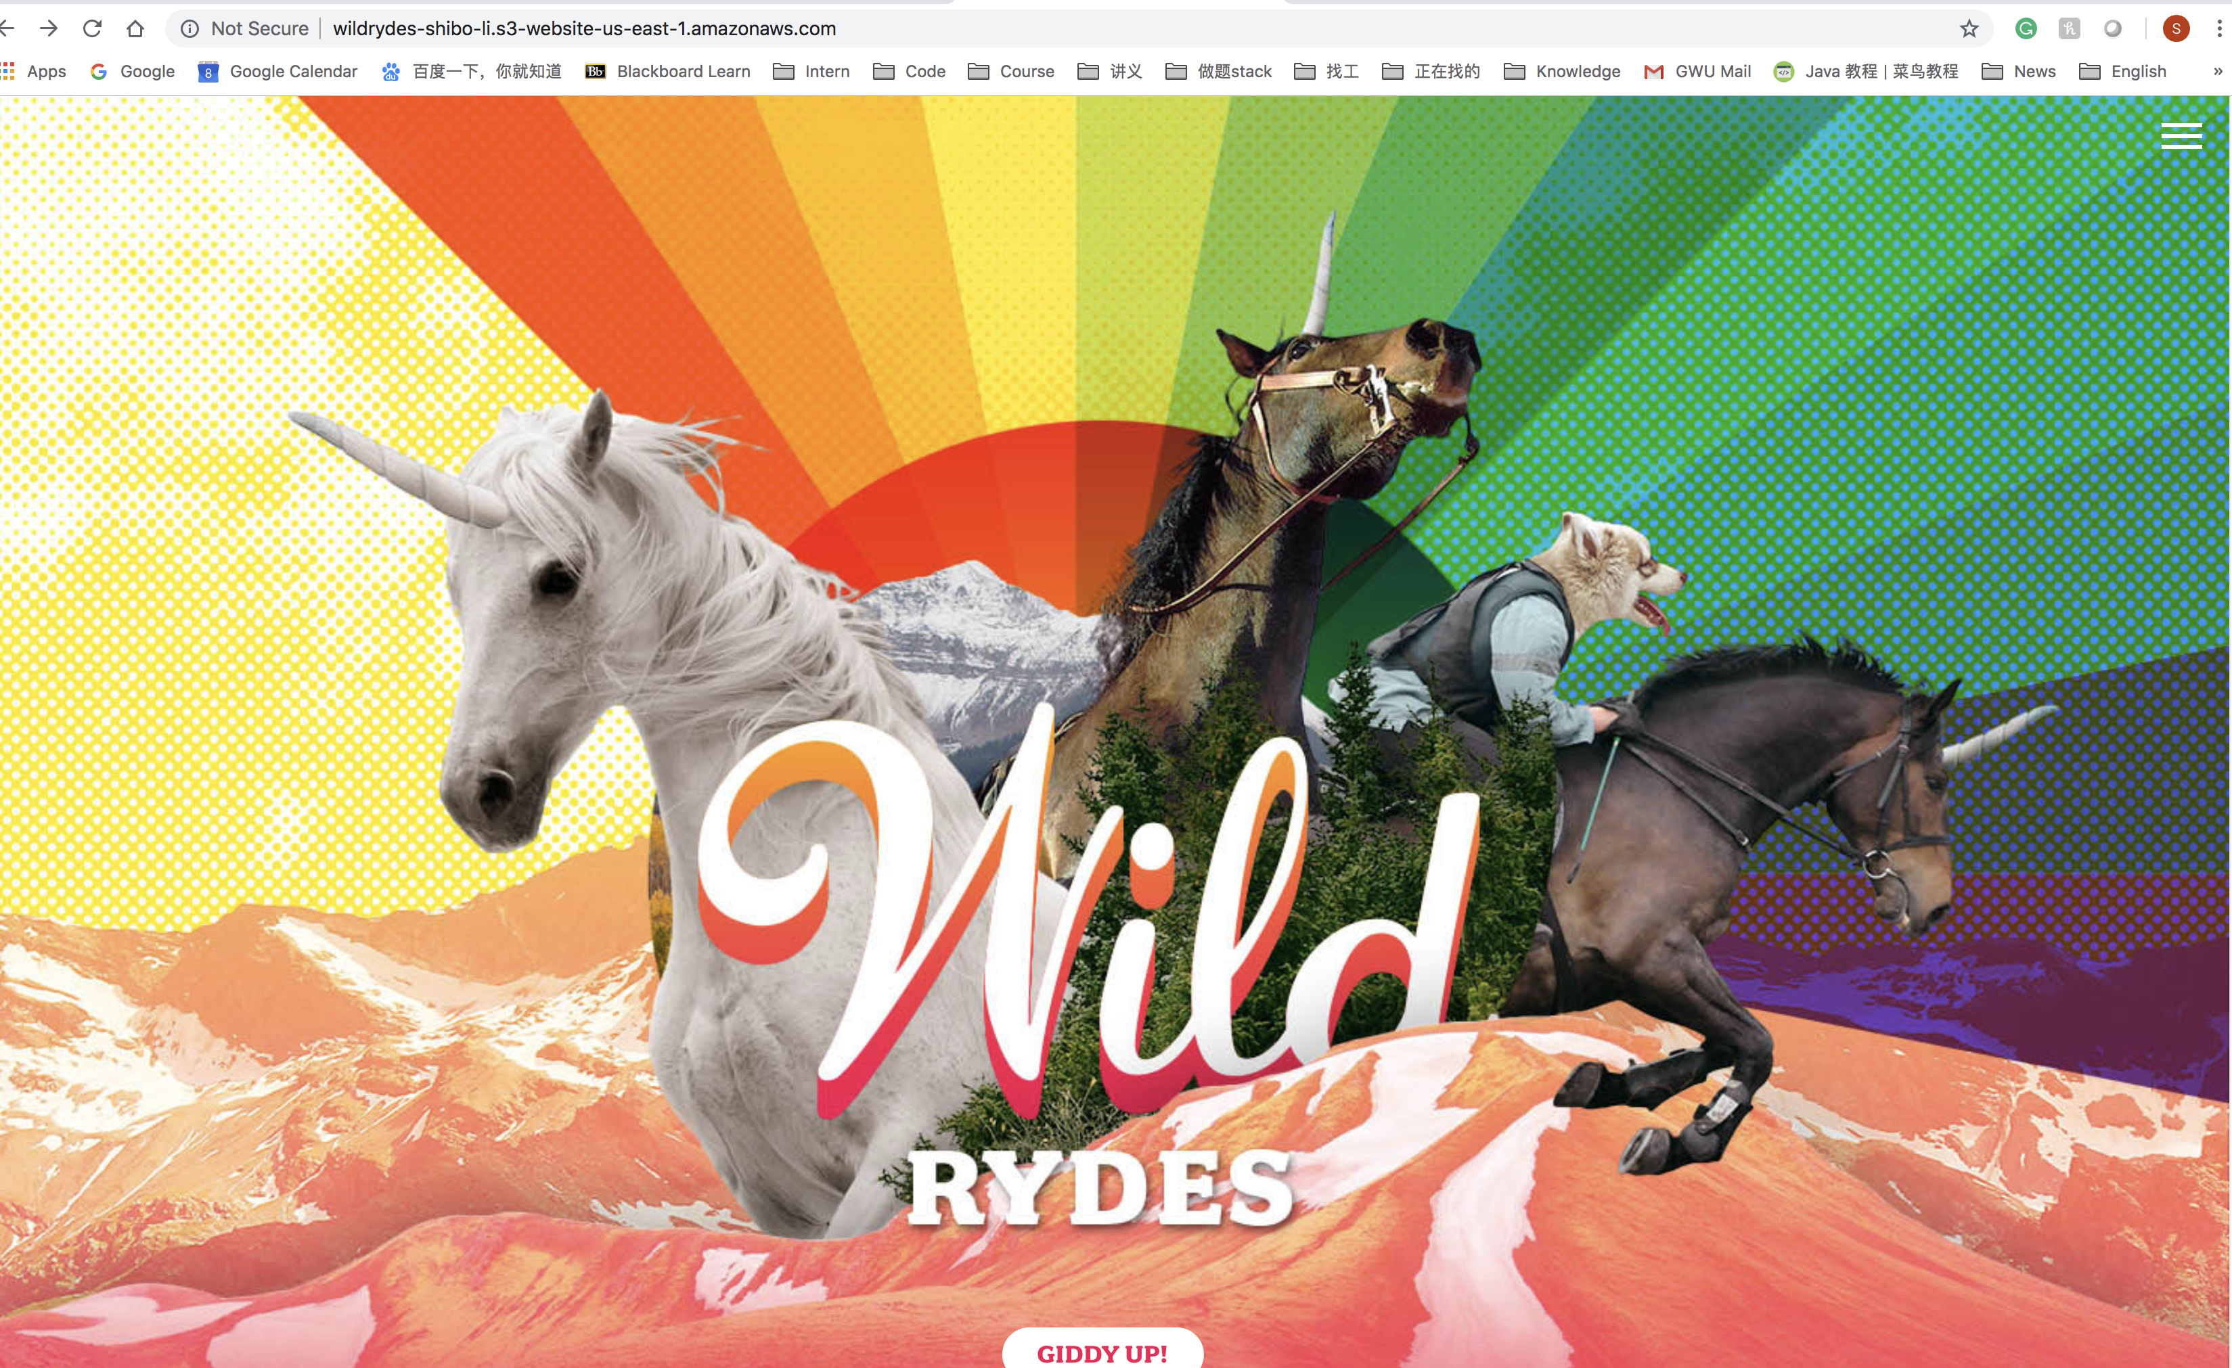

* New Config file

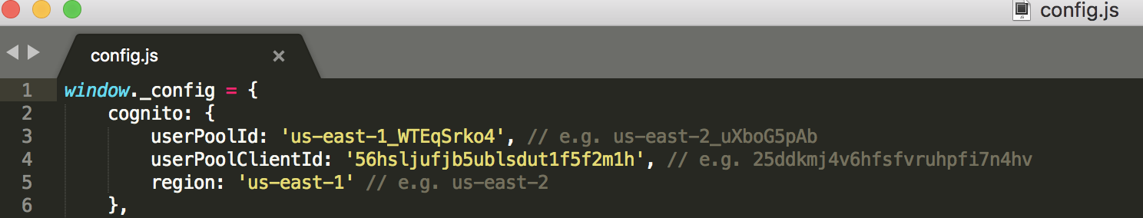

* Authentication success

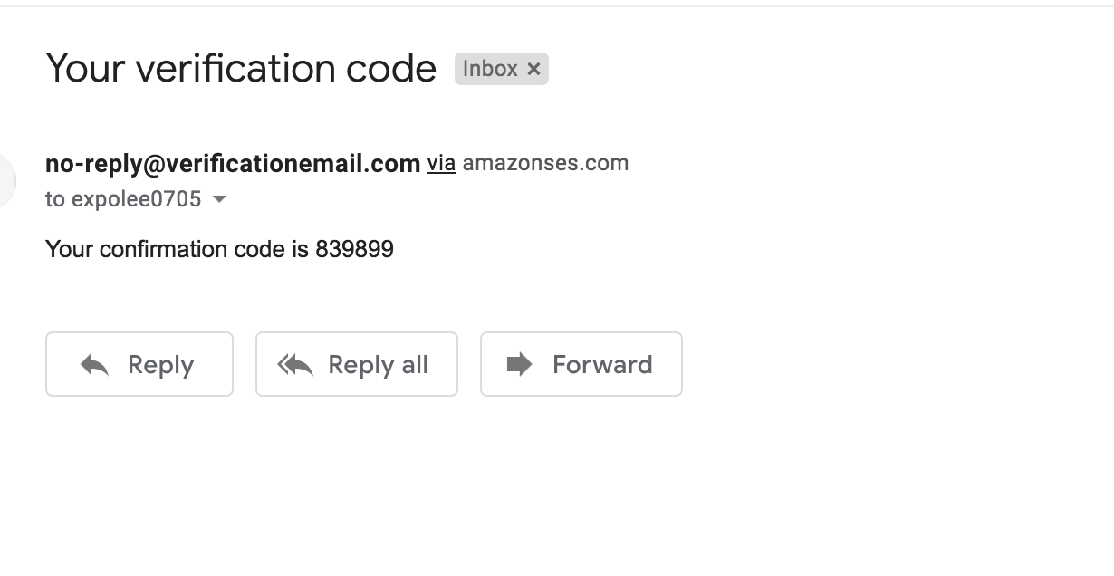

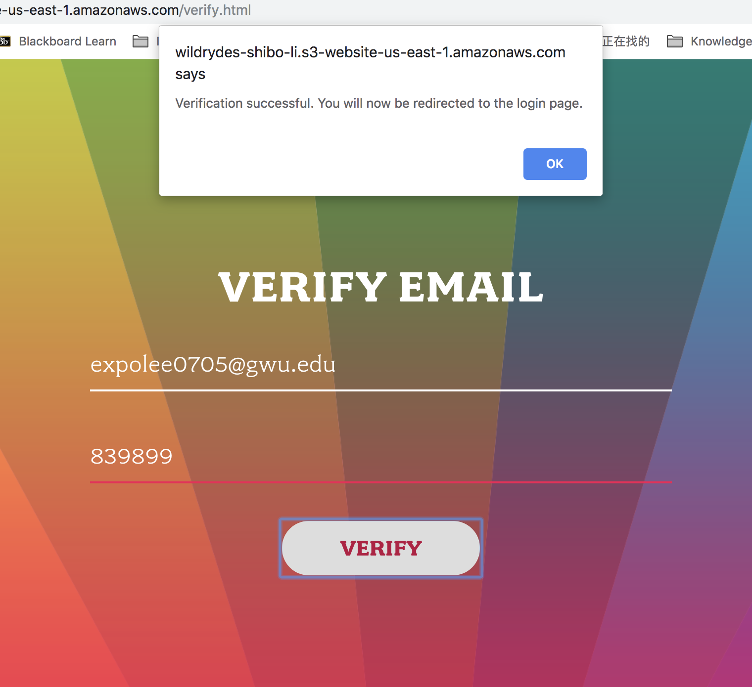

* Lambda function test successfully

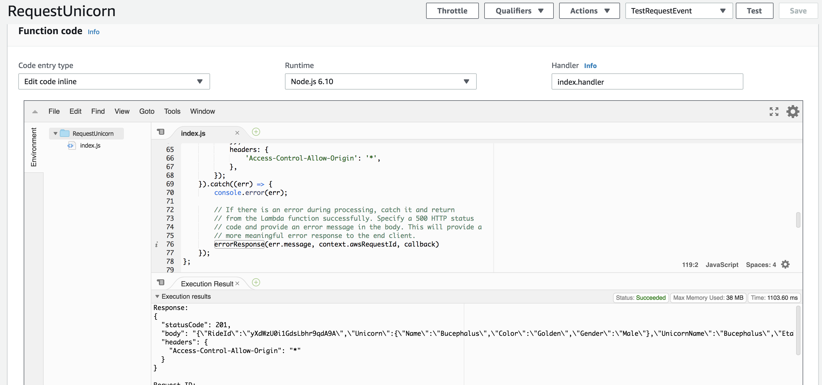

* Authorization by token

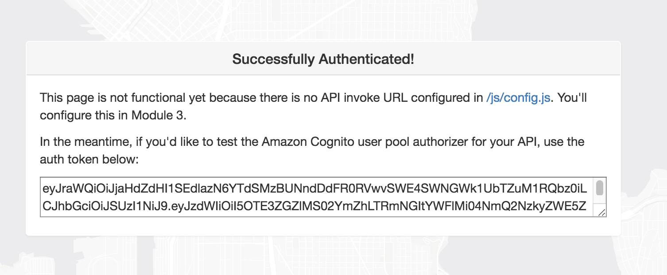

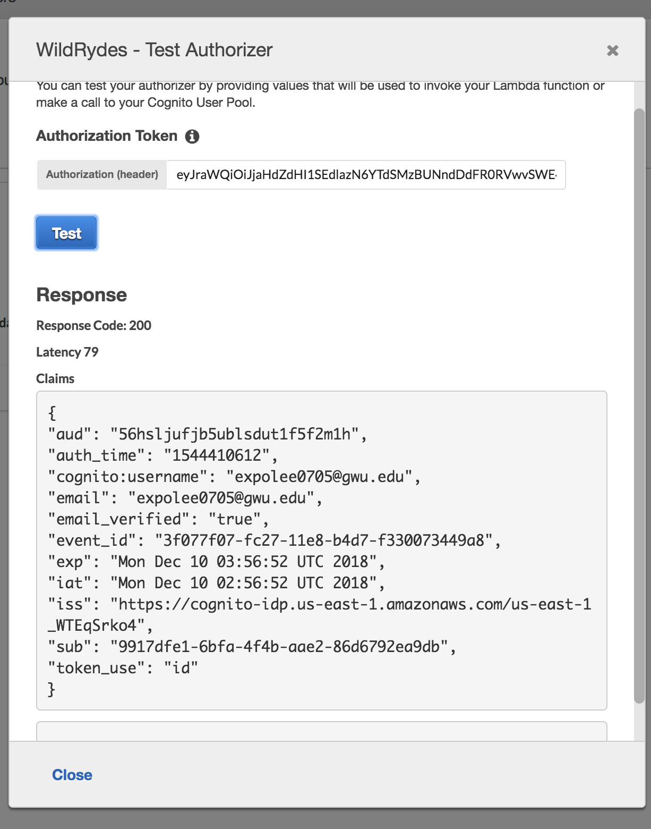

* **Finish deploy the API**

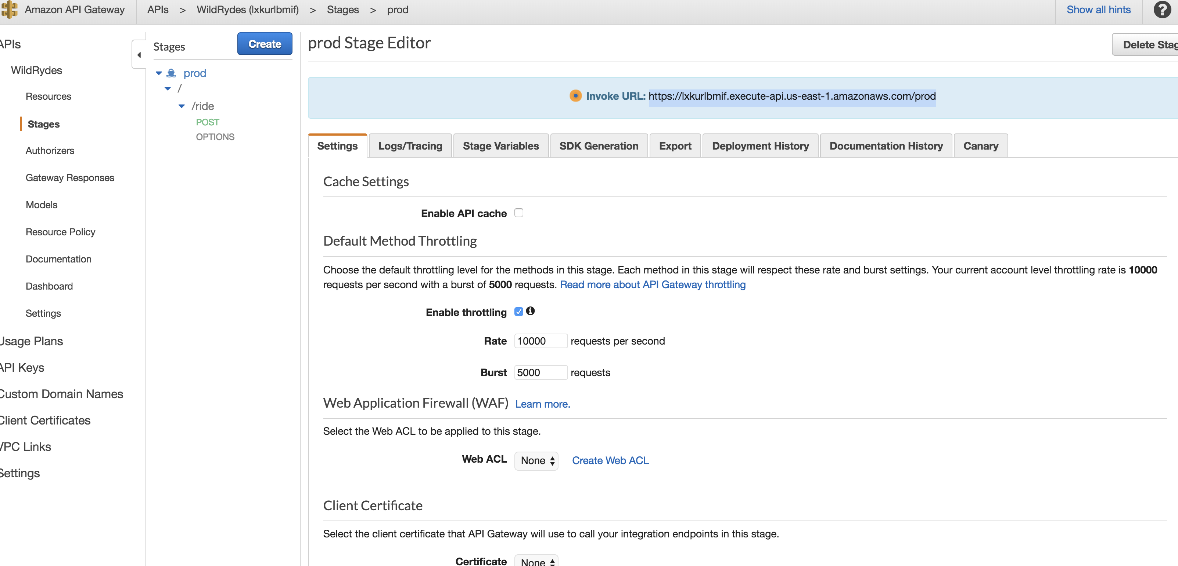

* **Implement the whole project**

